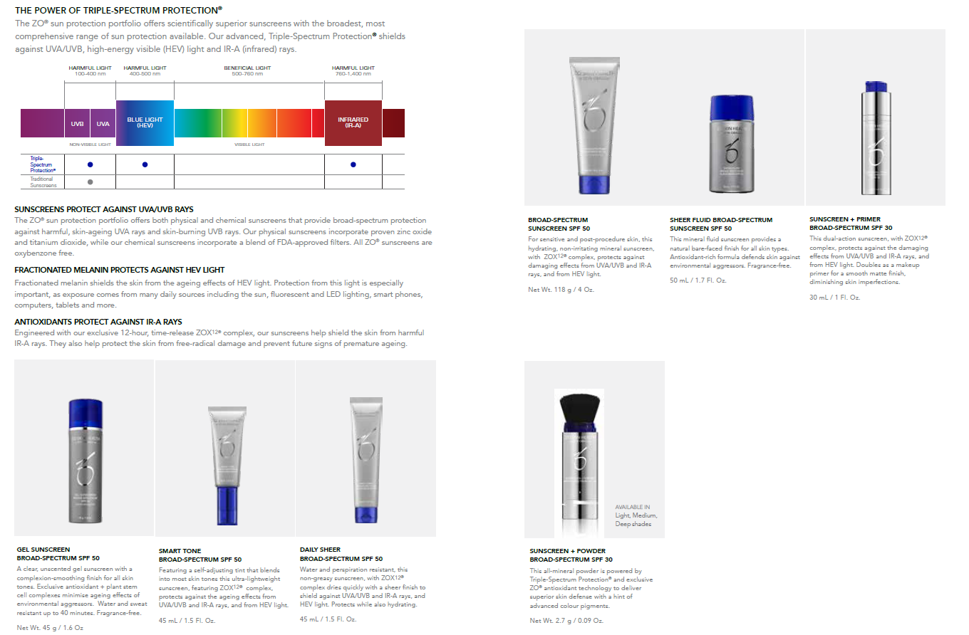

**SMART TONE**

**BROAD-SPECTRUM SPF50**

Featuring a self-adjusting tint that blends into most skin tones. Ultra lightweight. Leaves you with a lovely Sunkissed glow.

**GEL SUNSCREEN BROAD-SPECTRUM SPF 50**

Clear, unscented gel. Complexion smoothing finish for all skin tones. Water and sweat-resistant up to 40 mins. Fragrance free.

**DAILY SHEER**

**BROAD-SPECTRUM SPF50**

Water and perspiration resistant.

Non greasy.

**Chemical SPF-Water resistant**

**BROAD-SPECTRUM SUNSCREEN SPF 50**

For sensitive skin and post procedure. This is a hydrating non irritating mineral sunscreen.

**SHEER FLUID BROAD-SPECTRUM SUNSCREEN SPF 50**

This mineral fluid sunscreen provides a natural light weight finish for all skin types. Antioxidant rich formula defends against environmental aggressors. Fragrance free. Great for sensitive skin, post procedure.

**SUNSCREEN AND PRIMER**

**BROAD-SPECTRUM SPF 30**

Doubles as a makeup primer for a smooth matte finish. Silky smooth great under makeup, Diminishes skin imperfections.

ZO SPF

**Physical SPF- Good for sensitive skin and to apply post treatment.**

**All**

**All ZO SPF contains ZOX12 Complex which allows slow-release protection over 12 hours. Protecting against the damaging effects of UVA/UVB and IR-Rays and from HEV light emitted from our devices such as phones and laptops.**